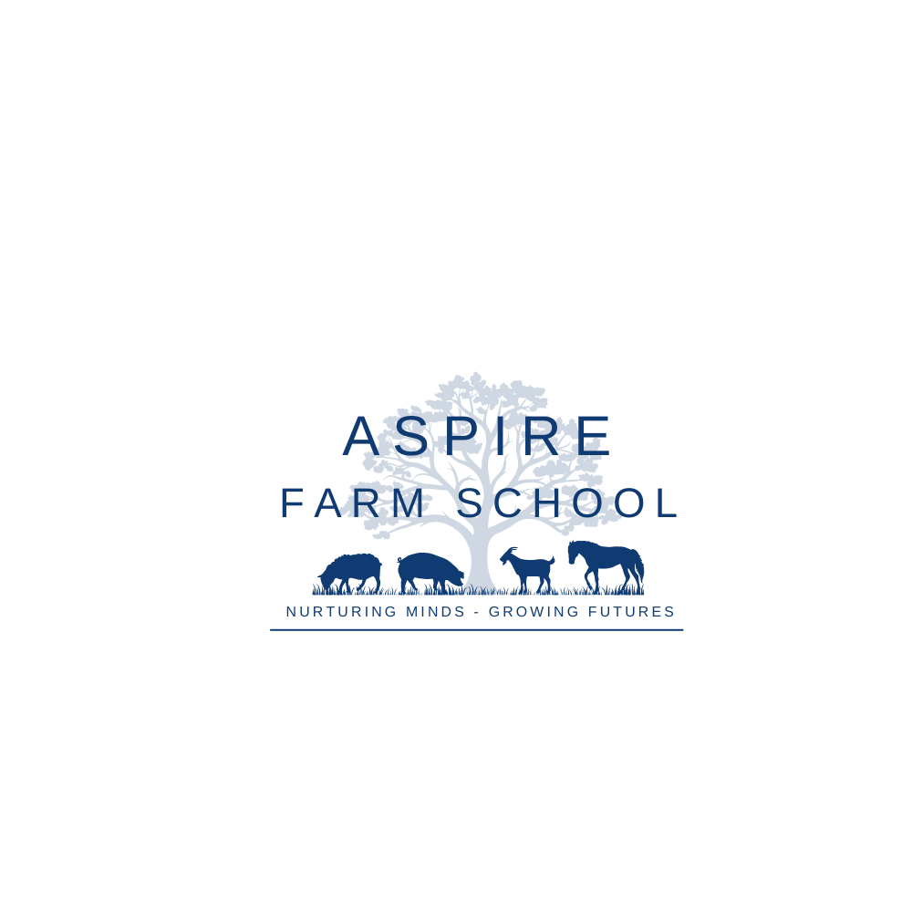



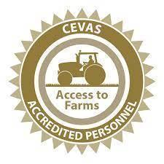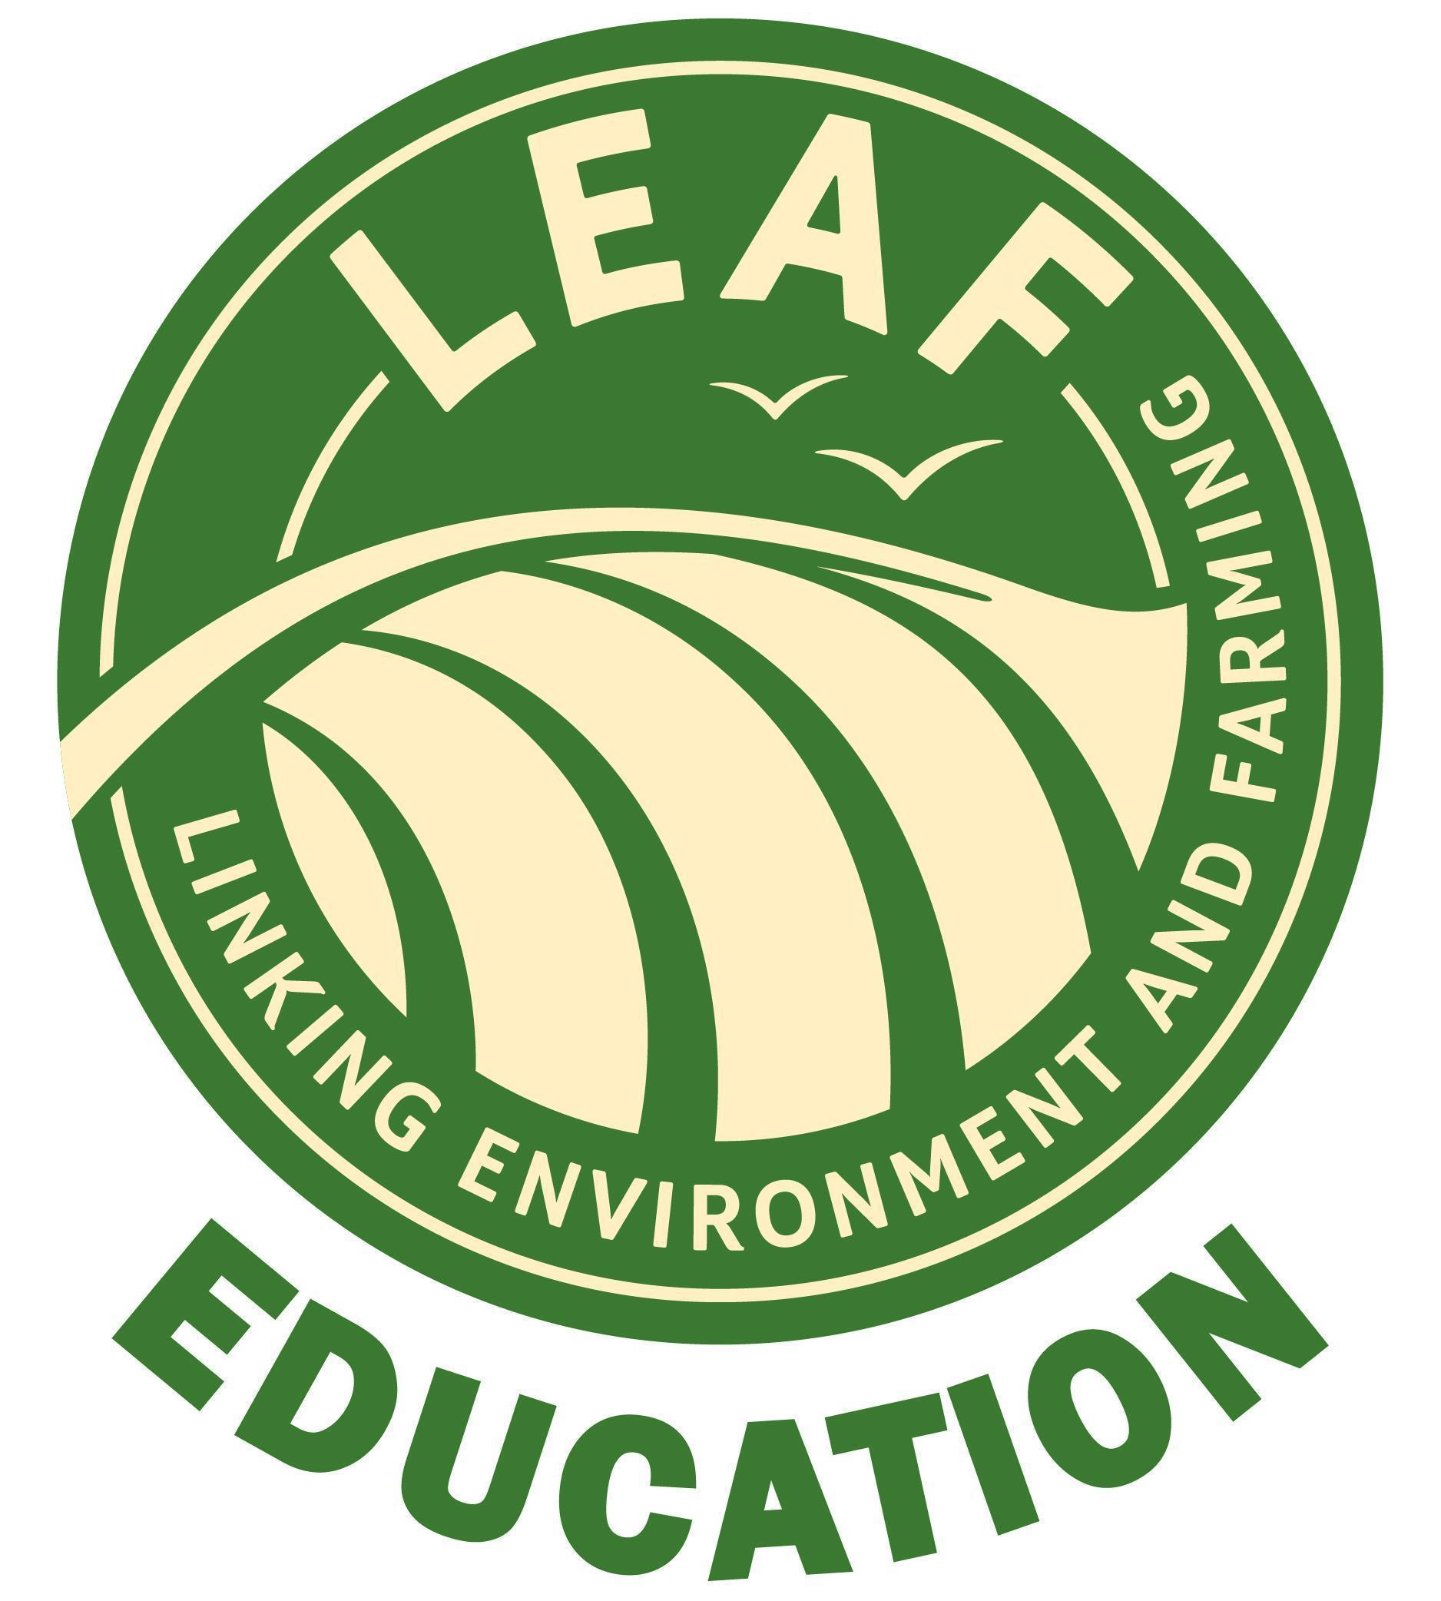

**Student Medical/Consent Form**

|  |  |  |  |
| --- | --- | --- | --- |
| Name of Student:- |  | | |
| Date of Birth:- |  | Age:- |  |
| Address:- |  | | |
| Parent/Guardian:- |  | | |
| Contacts in case of an emergency:- | Home:  Work: Mobile:  Alternative person: | | |
| Parent/Guardian/ Carer email address:- |  | | |

|  |  |  |
| --- | --- | --- |
| I consent to any emergency medical treatment necessary during the course of the visit/day/course. | Yes ⚪  No ⚪ | |
| Are there any **medical condition or allergies** we should know about? (eg: asthma, material, food, insect bites etc) | Yes ⚪  No ⚪ | |
| If yes, please give detail and treatment required:- | | |
| Name, address and telephone number of the child’s doctor:- | | |
| Do you feel that your child requires any additional support? | Yes ⚪  No ⚪ |
| If yes, please give details:- | |
|
| **Consent for Photography and Use of Images** | |
| **Internal Use:**  Do you, and your child, give permission for photos to be taken of them for internal use? These photos may be used for internal materials such as individual child reports and shared with the students' network (i.e. parent/carer/social worker etc). | Yes ⚪  No ⚪ |
| **External Use:**  Do you, and your child, give permission for photos to be taken of them for external use? These photos may be used for South Brockwells Farm School publicity on social media, the website, and other external publicity channels. | Yes ⚪  No ⚪ |

|  |  |
| --- | --- |
| Do you give permission for us to retain your information on our database?  This allows us to keep you up to date with our latest news and upcoming courses. Your information will be stored securely & confidentially, and never shared with third parties. It will be kept until you ask us to remove it, which you can do at any time with a phone call or email. | Yes ⚪  No ⚪ |
|  |  |
| Do you give permission for your child to travel with a member of the farm school team to complete farm duties?  It may be necessary during the course of the session for your child to travel across the farm in a farm vehicle (Van, Car or Mule (Kioti MEC2210). There may be occasions when your child will travel alone with a staff member. This will be in accordance with our Safeguarding Policy and Lone Working Policy. | Yes ⚪  No ⚪ |

|  |  |
| --- | --- |
| **Please read carefully**:-   * I have read the information above and give permission for my child to take part in Farm School. * I will ensure that my child carries with them their EpiPen and/or asthma inhaler (if applicable). * I have ensured that they understand that it is important for their safety and for the safety of others that any rules and instructions given by the staff are adhered to. * I will ensure that my child is wearing appropriate outdoor clothing/footwear and PPE if required. * I understand that, while Farm School staff in charge will take all reasonable care of the young people, they cannot be held responsible for any loss, damage or injury suffered by my child, unless they are negligent. | |
| Name (Parent/Guardian) :- ……………………………………………………………..(please print)  Signed (Parent/Guardian):- ……………………………………………………………. | Date:- |